Mind Mapping On Database Management Systems

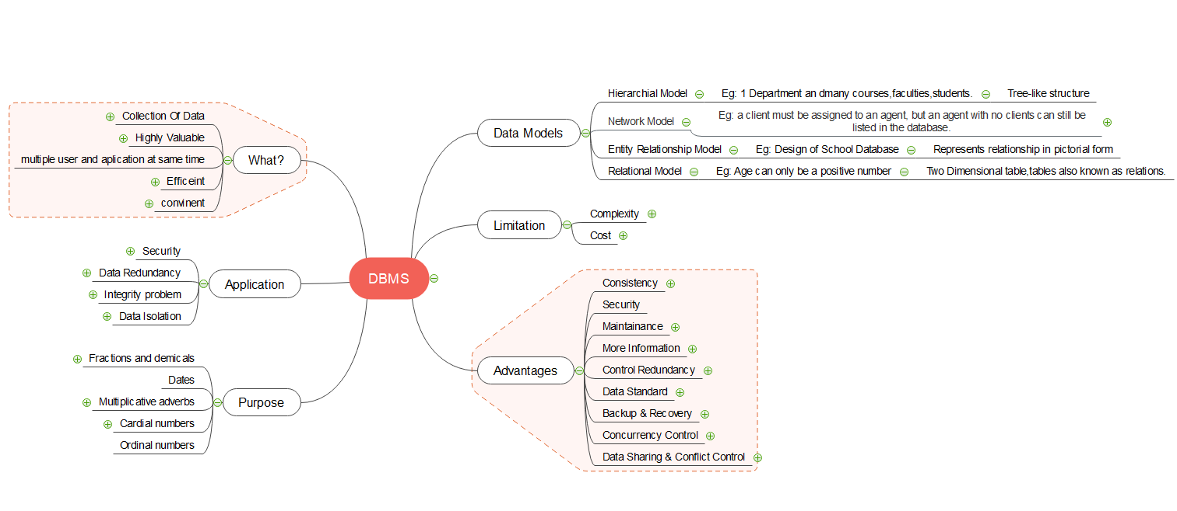

Mind Mapping On Business Communication and Value Science III (BCVS)

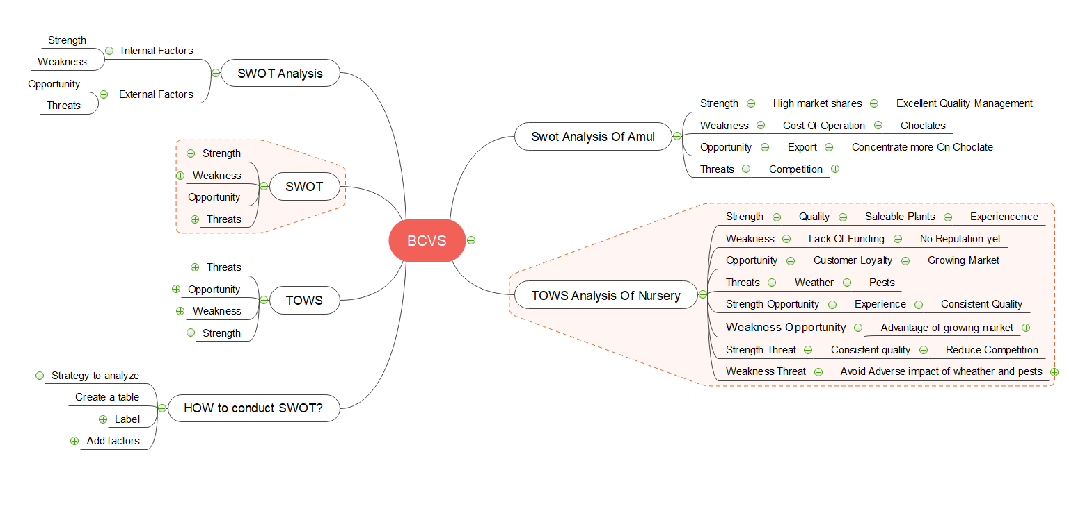

Mind Mapping On Operating Systems (OS)

